Good results have been obtained for the Time Reversal portion of the self-healing project. Multiple tests have been carried out in an attempt to prove that we can perform focusing using a Time Reversal method. These tests are all still carried out in the one-dimensional setting.

The setup for testing is very similar to the one that was mentioned in the previous quarterly report (November, 2009). The same custom tensioning system that is built on our optics table is still being used. The custom built amplifier, FPGA card and other computer/electronic hardware are also still in place. The rod that we are using is still made of steel and of the same diameter. The rod we are using now, however, is double the length of previous rod that was used; it is now two feet in length. The “defect” PZT that was used before has now been taken out of the main setup that we have been using. The algorithm we have been testing with recently is different from the previous one used. Because of this, we are looking at the focusing a little differently and do not require the “defect” PZT in that location for these tests. Below is a picture of the current setup to clarify what it is.

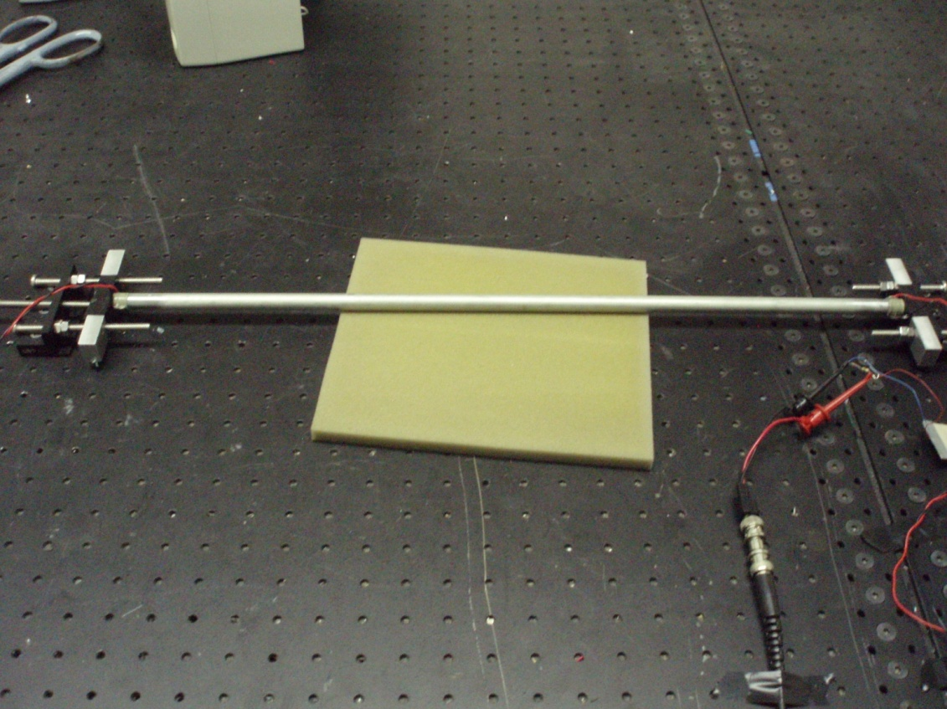

Figure Overview of current main setup for testing

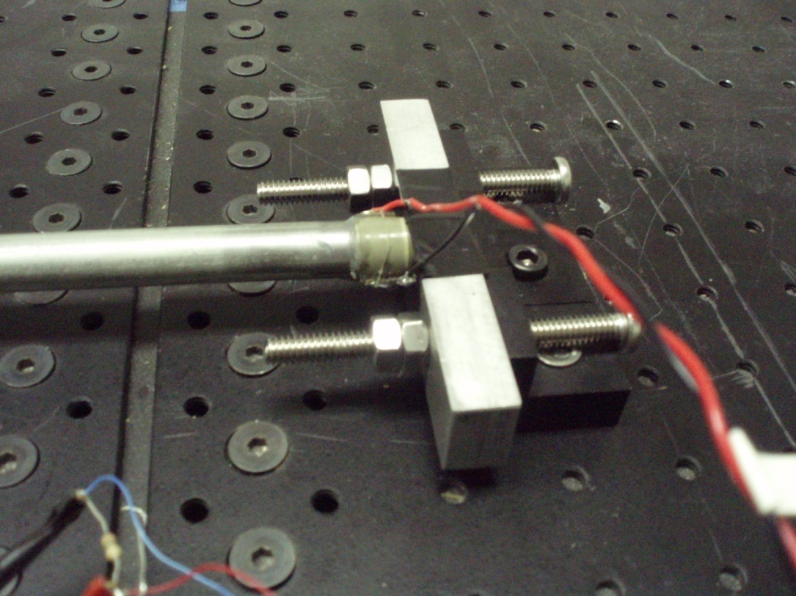

Figure PZT1 Close Up

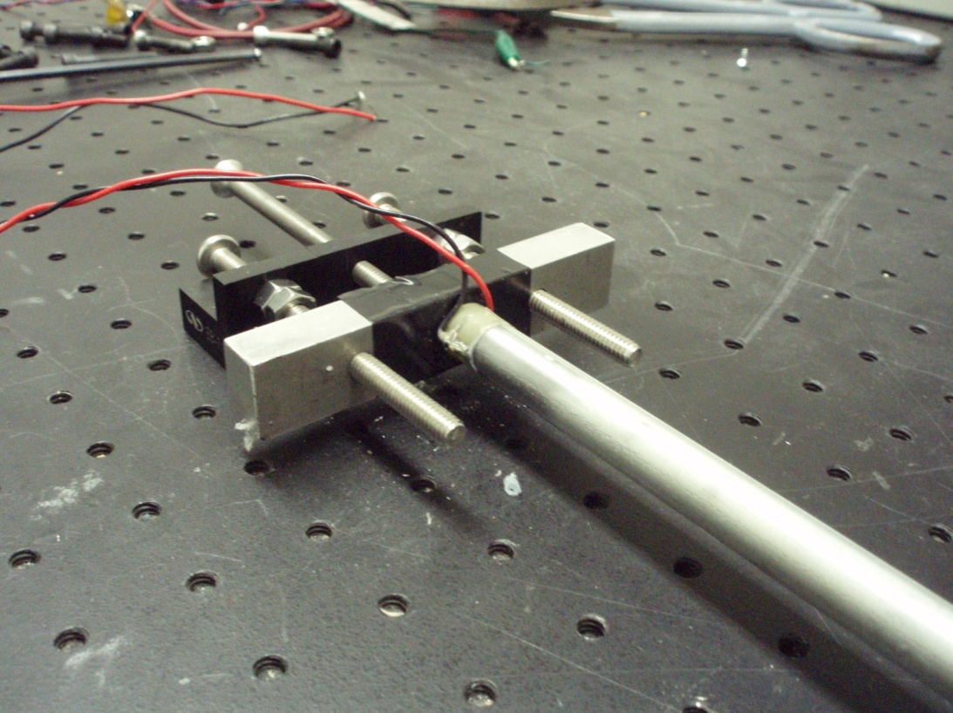

Figure PZT0 Close Up

The algorithm that has been used most recently is as follows:

1. PZT0 sends a Multi-Tone Pulse (a “chirp”) through the rod and towards PZT1.
2. PZT0 and PZT1 read in 1000 samples.
3. Using normalized correlation, the signal read by PZT0 is searched for the reflection of the pulse that was sent out. This reflection pulse will be the original pulse with a 180 phase shift.
4. The amplitude of this reflection pulse is recorded, along with the index in the signal that corresponds to the beginning of this pulse (i.e., the start where the reflection pulse was found).
5. This pulse is extracted, centered on zero and then rescaled to be maximum amplitude.
6. Steps 3-5 are performed on the signal read by PZT1, except it will just be looking for the original pulse that was sent by PZT0.
7. After obtaining the indexes for the start of where each pulse was found, and also the pulse itself, all of the other information in the signals is zeroed out. This means the signals that were read by each PZT will now only contain the pulses found. These pulses will be centered on zero and rescaled to max amplitude.
8. These modified signals are then completely reversed.
9. These reversed signals are then played back by the corresponding PZT that originally read them in.
10. PZT0 and PZT1 then read 1000 samples.
11. The signal from PZT0 is then parsed to try to find the reflection pulse. This process uses the normalized correlation again.
12. Once the reflected pulse is found (the original pulse shifted 180 degrees), its amplitude is recorded and compared to the amplitude from the reflection pulse in step 4.

Essentially what is happening is that PZT0 sends its pulse. PZT1 records this pulse. The pulse hits PZT1 and reflects back to PZT0 with a 180 phase shift. PZT0 records this reflection. During playback, PZT0 will playback the reversed reflection that it read in. This will travel towards PZT1. At the time it reaches PZT1and begins reflecting again is when PZT1 will begin to play out the reversed original pulse that it had read in. These two pulses (the one sent by PZT0 and the one being played out by PZT1) will combine together and travel back towards PZT0. This causes PZT0 to receive the combined amplitudes of the reflection pulse and the pulse played out by PZT1. This is greater amplitude then could be achieved by either pulse alone.

We have switched to using a multi-tone pulse instead of a single tone pulse because we not only get better excitation, but we are also more easily able to find this pulse in the signals that are read in by each PZT. We switched to using a longer rod in order to accommodate this longer pulse. The pulse we are using consists of a 130Khz pulse in the center, a 110Khz pulse on both sides of it, and then a 90Khz pulse to the outside of each of the 110Khz pulse. These are stringed together to form a single, multi-tone pulse. You can see the additional “defect” PZT is not needed for these particular tests because we are proving focusing at PZT0; the original sending PZT itself.

Results so far have been very consistent and encouraging. Everything seems to be working exactly as described above. Below are graphs and the tables of results for this setup.

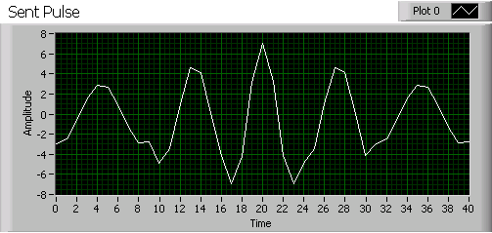

Figure 4 Initial multi-tone pulse sent by PZT0. This is what the algorithm searches for in the signal read by PZT1.

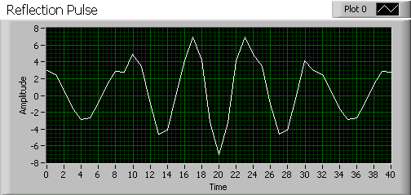

Figure Reflection of the multi-tone pulse. Notice it is just the multi-tone pulse phase shifted 180 degrees. This is what the algorithm searches for in the signal read by PZT0.

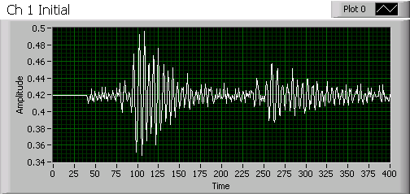

Figure Recording from PZT1 during step 2.The initial pulse starts to appear at the 82nd sample.

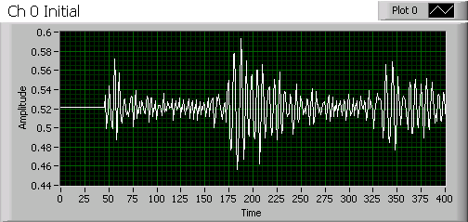

Figure Recording from PZT0 during step 2. The reflected pulse starts to appear at the 164th sample.

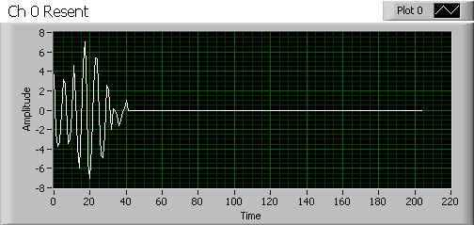

Figure Signal that is played out by PZT0 during step 9. It is the rescaled, centered, and reversed reflection pulse that was received. Since this was read last, it will be played back first. Everything else is zeroed out.

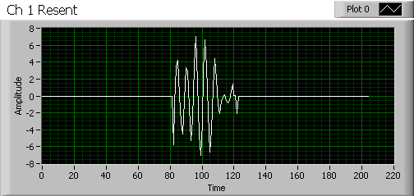

Figure Signal that is played out by PZT1 during step 9. It is the rescaled, centered, and reversed initial pulse that was received. Since this was read first, it will be sent out last. The data in front and behind of the pulse are zeroed out. Remember that it takes approximately 82 time units for the pulse to travel from one side of the rod to the other. When the pulse that is resent from PZT0 reaches the other end (at 82 time units), then PZT1 begins playing out its pulse. This is where the combination occurs. This combination of waves then travels back towards PZT0.

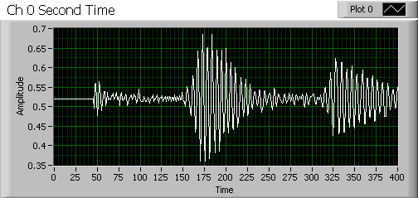

Figure Recording from PZT0 during step 10. The reflected pulse starts to appear at the 164th sample again, except this time it has greater amplitude and appears to be much more defined due to the combination of the reflected pulse and the pulse played out from PZT1.

|  |  |
| --- | --- |
| PZT0 Initial Reflection Amplititude | 147.135 mV |
| PZT0 Reversal Reflection Amplitude | 333.374 mV |
| PZT0 Reversal Reflection Amplitude with only PZT1 replaying a signal | 194.213 mV |
| PZT0 Reversal Reflection Amplitude with only PZT0 replaying a signal | 173.584 mV |

Figure Table showing the amplitude of the reflection pulse recorded at PZT0. Notice that the reversal reflection amplitude is more than double the amplitude of the initial reflection pulse recorded. Another item to note is that if you sum the amplitudes recorded for the single channel playbacks it is close to equaling the amplitude that is achieved when both channels are used during the time reversal, which further implies that the pulses are combining during the time reversal. Also notice that when PZT0 alone plays back during the time reversal portion, the reflection it receives is stronger than the reflection received in the initial pulse sending (step 2). This is consistent with another form of the Time-Reversal known as the Iterative Time-Reversal process.

We have also used this algorithm on two other setups that are similar. For one of the additional setups, everything stayed the same except we machined a semi-circle into the middle of a steel rod that has the same dimensions as two foot steel rod used in the previous test. This semi-circle allows for us to place a hoop mode PZT in the middle of the rod. During step 2 of the algorithm, we also read in at this PZT. We record the max amplitude that is reached at that point. During step 10, we do the same thing and compare the max amplitude read during step 10 to that of step 2. Preliminary results for this have proven to be optimistic. Although we are not performing a direct focusing at this point alone, we can show that the combination of the waves during playback causes increased amplitude throughout the whole system.

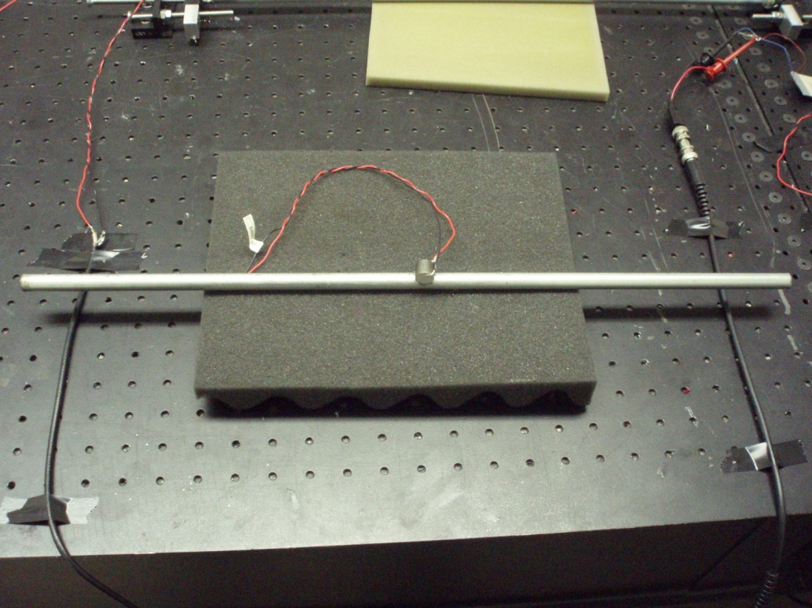

Figure Overview of setup with a hoop mode transducer placed in a semi-circle that was machined at the middle of the rod. During testing, this would be placed into the tensioning system with the PZTs on either end just like the first setup has.

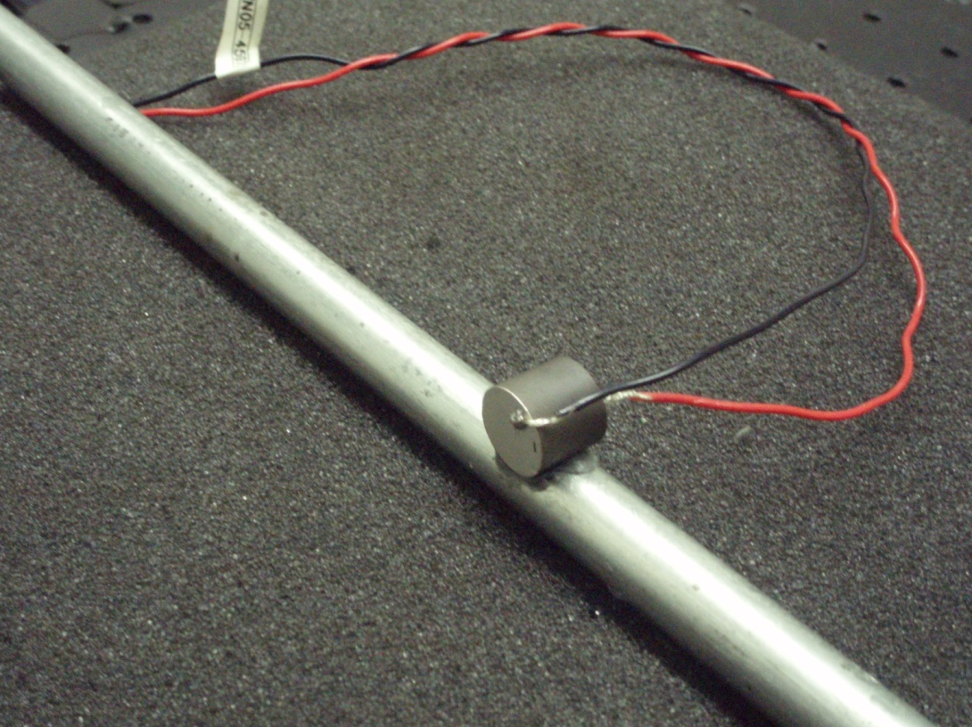

Figure Close up of hoop mode transducer that reads at the defect point.

For the other additional setup, everything remained the same as the test that was first mentioned in this report, except that a thin, square, PZT wafer was placed between the rod and PZT1. Similarly to the tests with the hoop mode PZT, we read in at the square wafer PZT during step 2 and step 10. The max amplitudes for each step were compared to each other. So far, it appears that we are able to focus at this wafer during the playback. This proves more of what we want; to have a localized focusing at one point and not across the whole system. Further tests will need to be carried out in order to prove this. The data so far, however, has been very supportive that we are indeed performing focusing at that point.

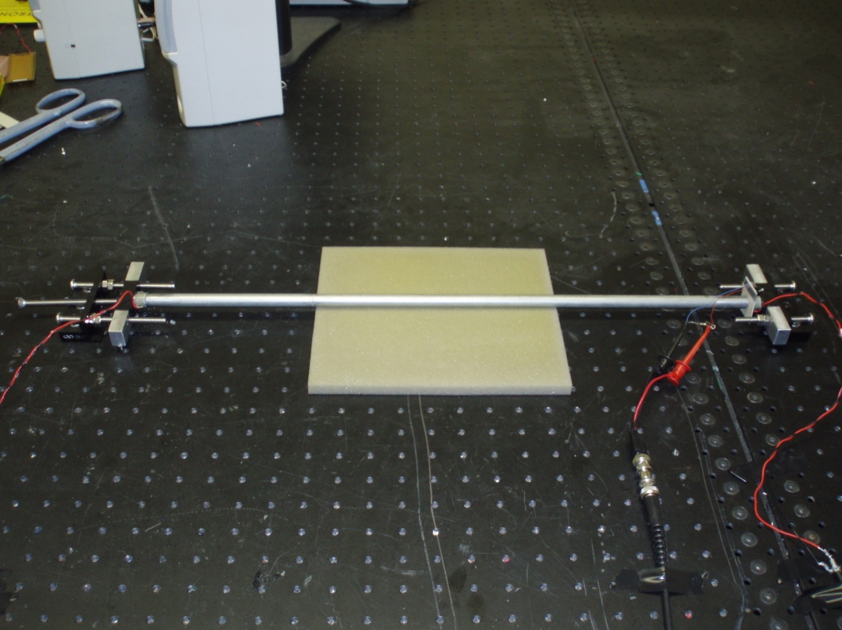

Figure Overview of setup with the PZT wafer placed between PZT1 and the steel rod (right side)

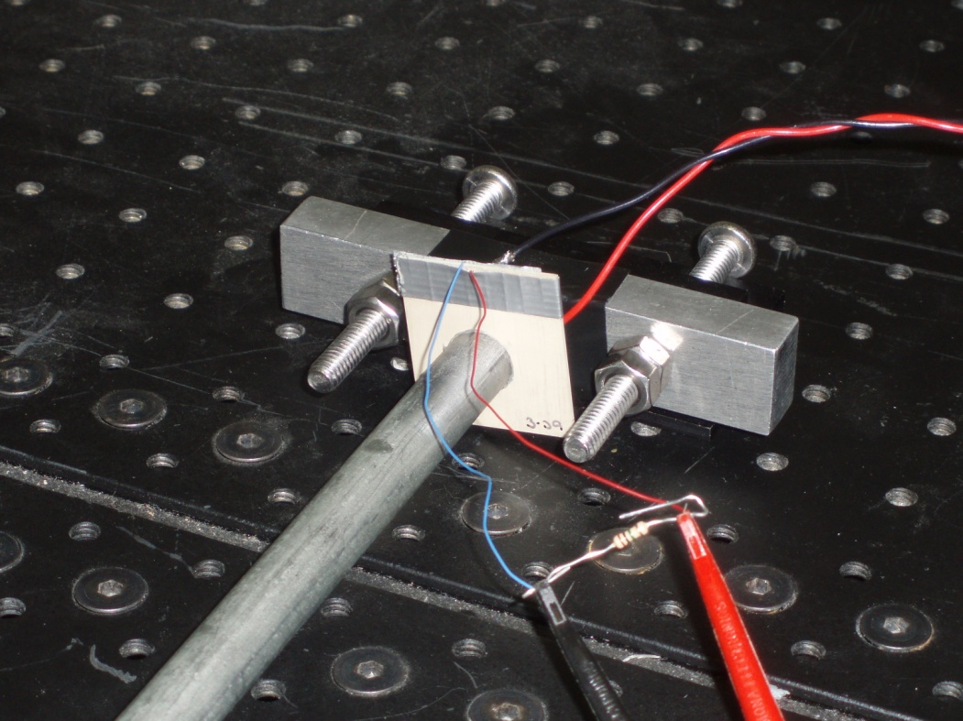

Figure Close up of the PZT wafer in the test setup.

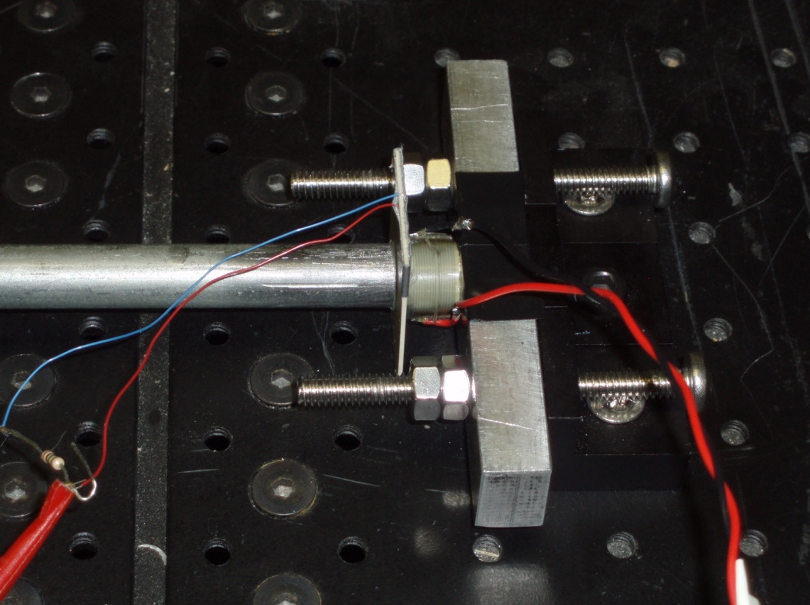

Figure Side view close up of the PZT wafer in the test setup.